Article ID: 3127
Article Name The red Led of my freezer is lit
Topic Location: Cooling/Chest Freezer/Error codes-Alarms/Display
Meta-data: light, lamp , table top
Related Articles:
Related Questions:
PNC
DIY
Safety
Link
Email
x Book Engineer
Multimedia
Brand
Article Content:
If the red light is lit, it can have several causes.
- It’s possible that too much warm food has been placed in the appliance at once.
- The door has been open too long, or not closed properly
- There is a high or too low surrounding temperature:
The proper operation can only be guaranteed for a SN-class appliance in an ambient temperature of +10°C to +32°C.
- Class N = 16-32°C
- Class SN = 10-32°C
- Class ST = 18-38°C
- Class SN/T = 10-38°C
Climate classification indication on rating plate:
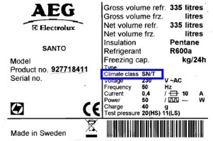

If none of the above is the problem a service engineer can resolve it for you.
[book_engineer_link]

